Circle

Definition
# Source: AI Source: Provided by: [Data Path: Persons Table -> ID Column: 1, Name_En Column: Motasem Essam] -> From: [ChatGPT] on [7/25/2026]
A circle is a set of all points in a plane that are at the same fixed distance from a fixed point.
The fixed point is called the center, and the fixed distance is called the radius.
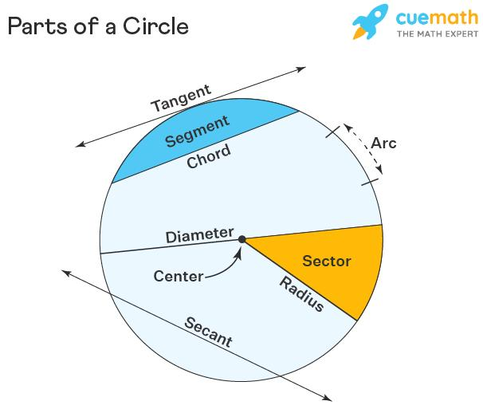
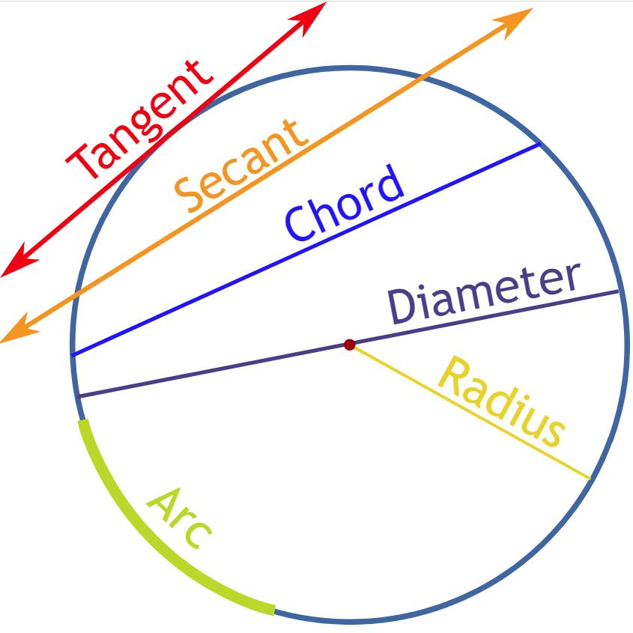
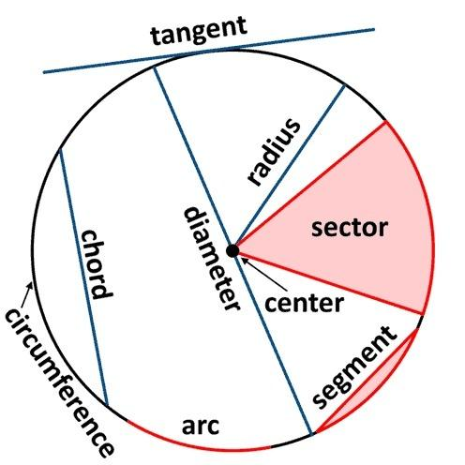
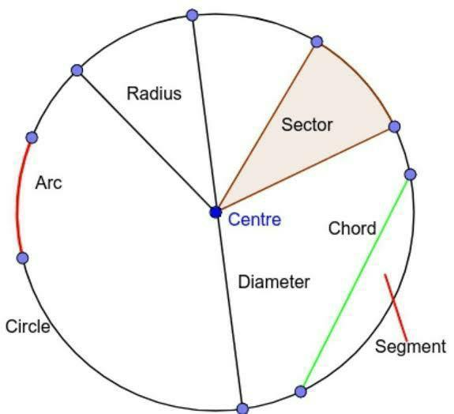
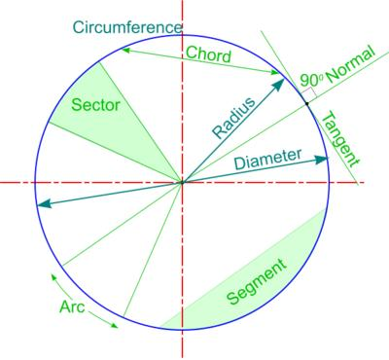

Fundamental Elements
# Source: AI Source: Provided by: [Data Path: Persons Table -> ID Column: 1, Name_En Column: Motasem Essam] -> From: [ChatGPT] on [7/25/2026]
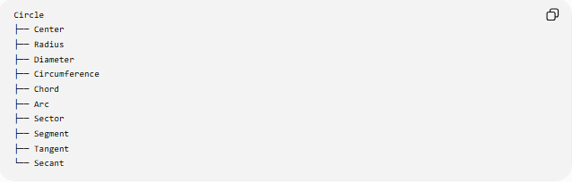
Circle
├── Center
├── Radius
├── Diameter
├── Circumference
├── Chord
├── Arc
├── Sector
├── Segment
├── Tangent
└── Secant
1. Center
The center is the fixed point from which every point on the circle is the same distance.
Usually denoted by $O$.
2. Radius
A radius is a line segment from the center to any point on the circle.
$$\boxed{r=\text{radius}}$$
All radii of the same circle have equal length.
3. Diameter
A diameter is a chord that passes through the center.
$$\boxed{d=2r}$$
The diameter is the longest chord of a circle.
4. Circumference
The circumference is the distance around the circle.
$$\boxed{C=2πr}$$
or
$$\boxed{C=πd}$$
5. Chord
A chord is a line segment whose endpoints lie on the circle.
Every diameter is a chord, but not every chord is a diameter.
6. Arc
An arc is a portion of the circumference between two points on the circle.
7. Sector
A sector is the region bounded by two radii and the arc between them.
8. Segment
A segment of a circle is the region bounded by a chord and its corresponding arc.
9. Tangent
A tangent line touches a circle at exactly one point.
The radius to the point of tangency is perpendicular to the tangent:
$$\boxed{r⊥\text{tangent}}$$
10. Secant
A secant line intersects a circle at two points.

Mathematical Representation
# Source: AI Source: Provided by: [Data Path: Persons Table -> ID Column: 1, Name_En Column: Motasem Essam] -> From: [ChatGPT] on [7/25/2026]
A circle centered at the origin with radius $r$has equation:
$$\boxed{x^{2}+y^{2}=r^{2}}$$
A circle with center $\left(h , k\right)$and radius $r$has equation:
$$\boxed{{\left(x-h\right)}^{2}+{\left(y-k\right)}^{2}=r^{2}}$$
For example, a circle centered at $\left(2 , 3\right)$with radius $5$:
$$\boxed{{\left(x-2\right)}^{2}+{\left(y-3\right)}^{2}=25}$$
Area
The area enclosed by a circle is:
$$\boxed{A=πr^{2}}$$
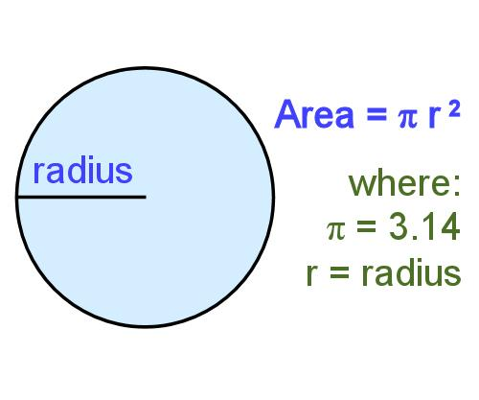
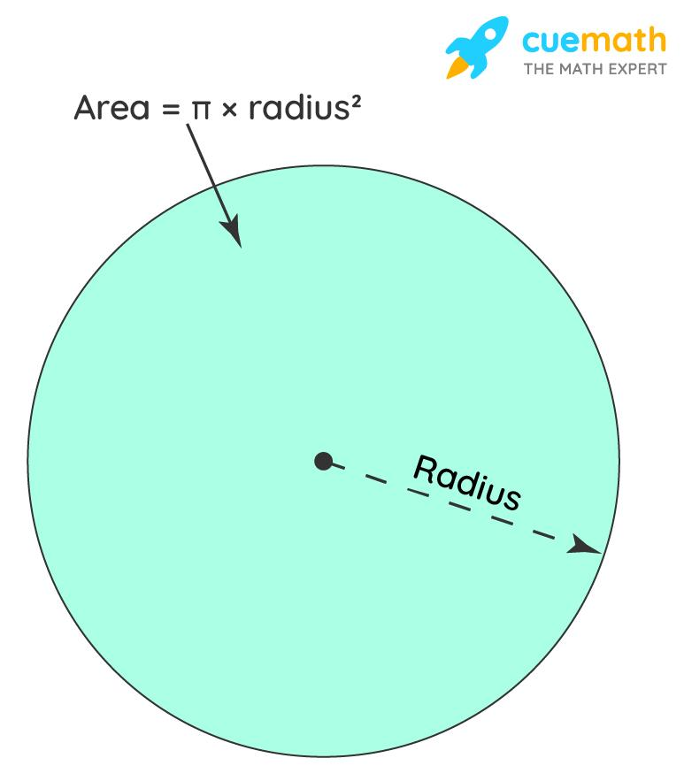
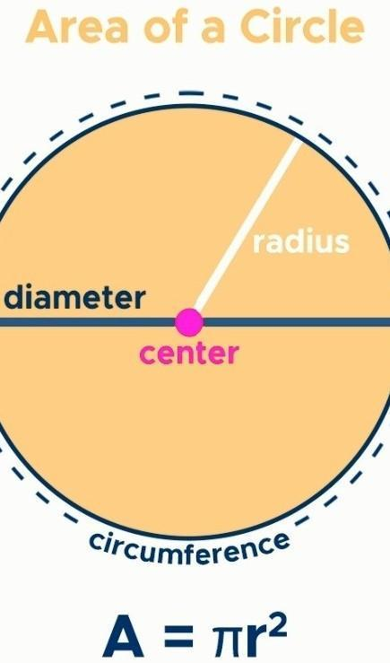
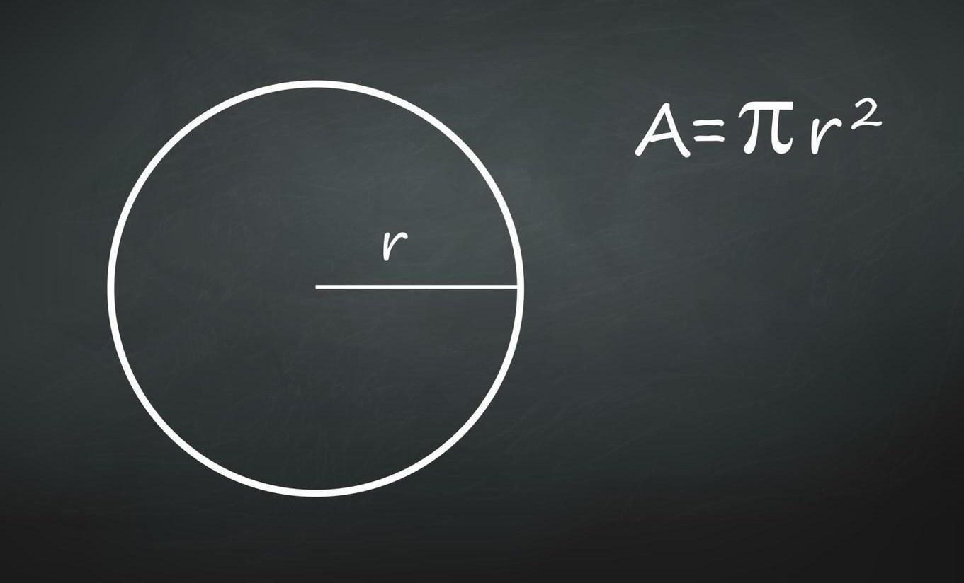
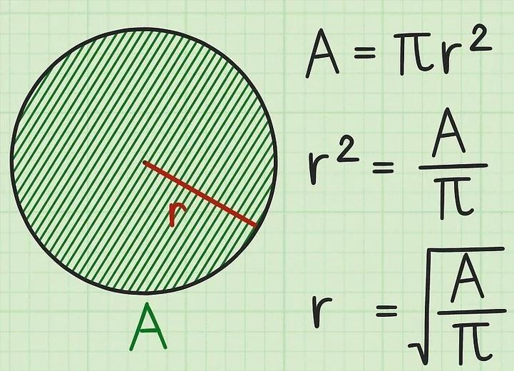
Circumference
$$\boxed{C=2πr}$$
Since $d=2r$:
$$\boxed{C=πd}$$
Diameter and Radius Relationship
$$\boxed{d=2r}$$
and
$$\boxed{r=\frac{d}{2}}$$
For example, if $r=7$:
$$d=2\left(7\right)=14$$

Main Properties
# Source: AI Source: Provided by: [Data Path: Persons Table -> ID Column: 1, Name_En Column: Motasem Essam] -> From: [ChatGPT] on [7/25/2026]
- Every point on the circle is equally distant from the center.
- All radii of a circle are congruent.
- The diameter is twice the radius.
- The diameter is the longest chord.
- A diameter divides a circle into two semicircles.
- A radius perpendicular to a chord bisects that chord.
- Equal chords are equidistant from the center.
- Equal chords subtend equal central angles.
- The perpendicular bisector of every chord passes through the center.
- A tangent touches the circle at exactly one point.
- The radius to a point of tangency is perpendicular to the tangent.

Angles in a Circle

Central Angle
# Source: AI Source: Provided by: [Data Path: Persons Table -> ID Column: 1, Name_En Column: Motasem Essam] -> From: [ChatGPT] on [7/25/2026]
A central angle has its vertex at the center.
The measure of a central angle equals the measure of its intercepted arc.
$$\boxed{m∠AOB=m\hat{AB}}$$

Inscribed Angle
# Source: AI Source: Provided by: [Data Path: Persons Table -> ID Column: 1, Name_En Column: Motasem Essam] -> From: [ChatGPT] on [7/25/2026]
An inscribed angle has its vertex on the circle.
Its measure is half the measure of its intercepted arc:
$$\boxed{m∠ACB=\frac{1}{2}m\hat{AB}}$$
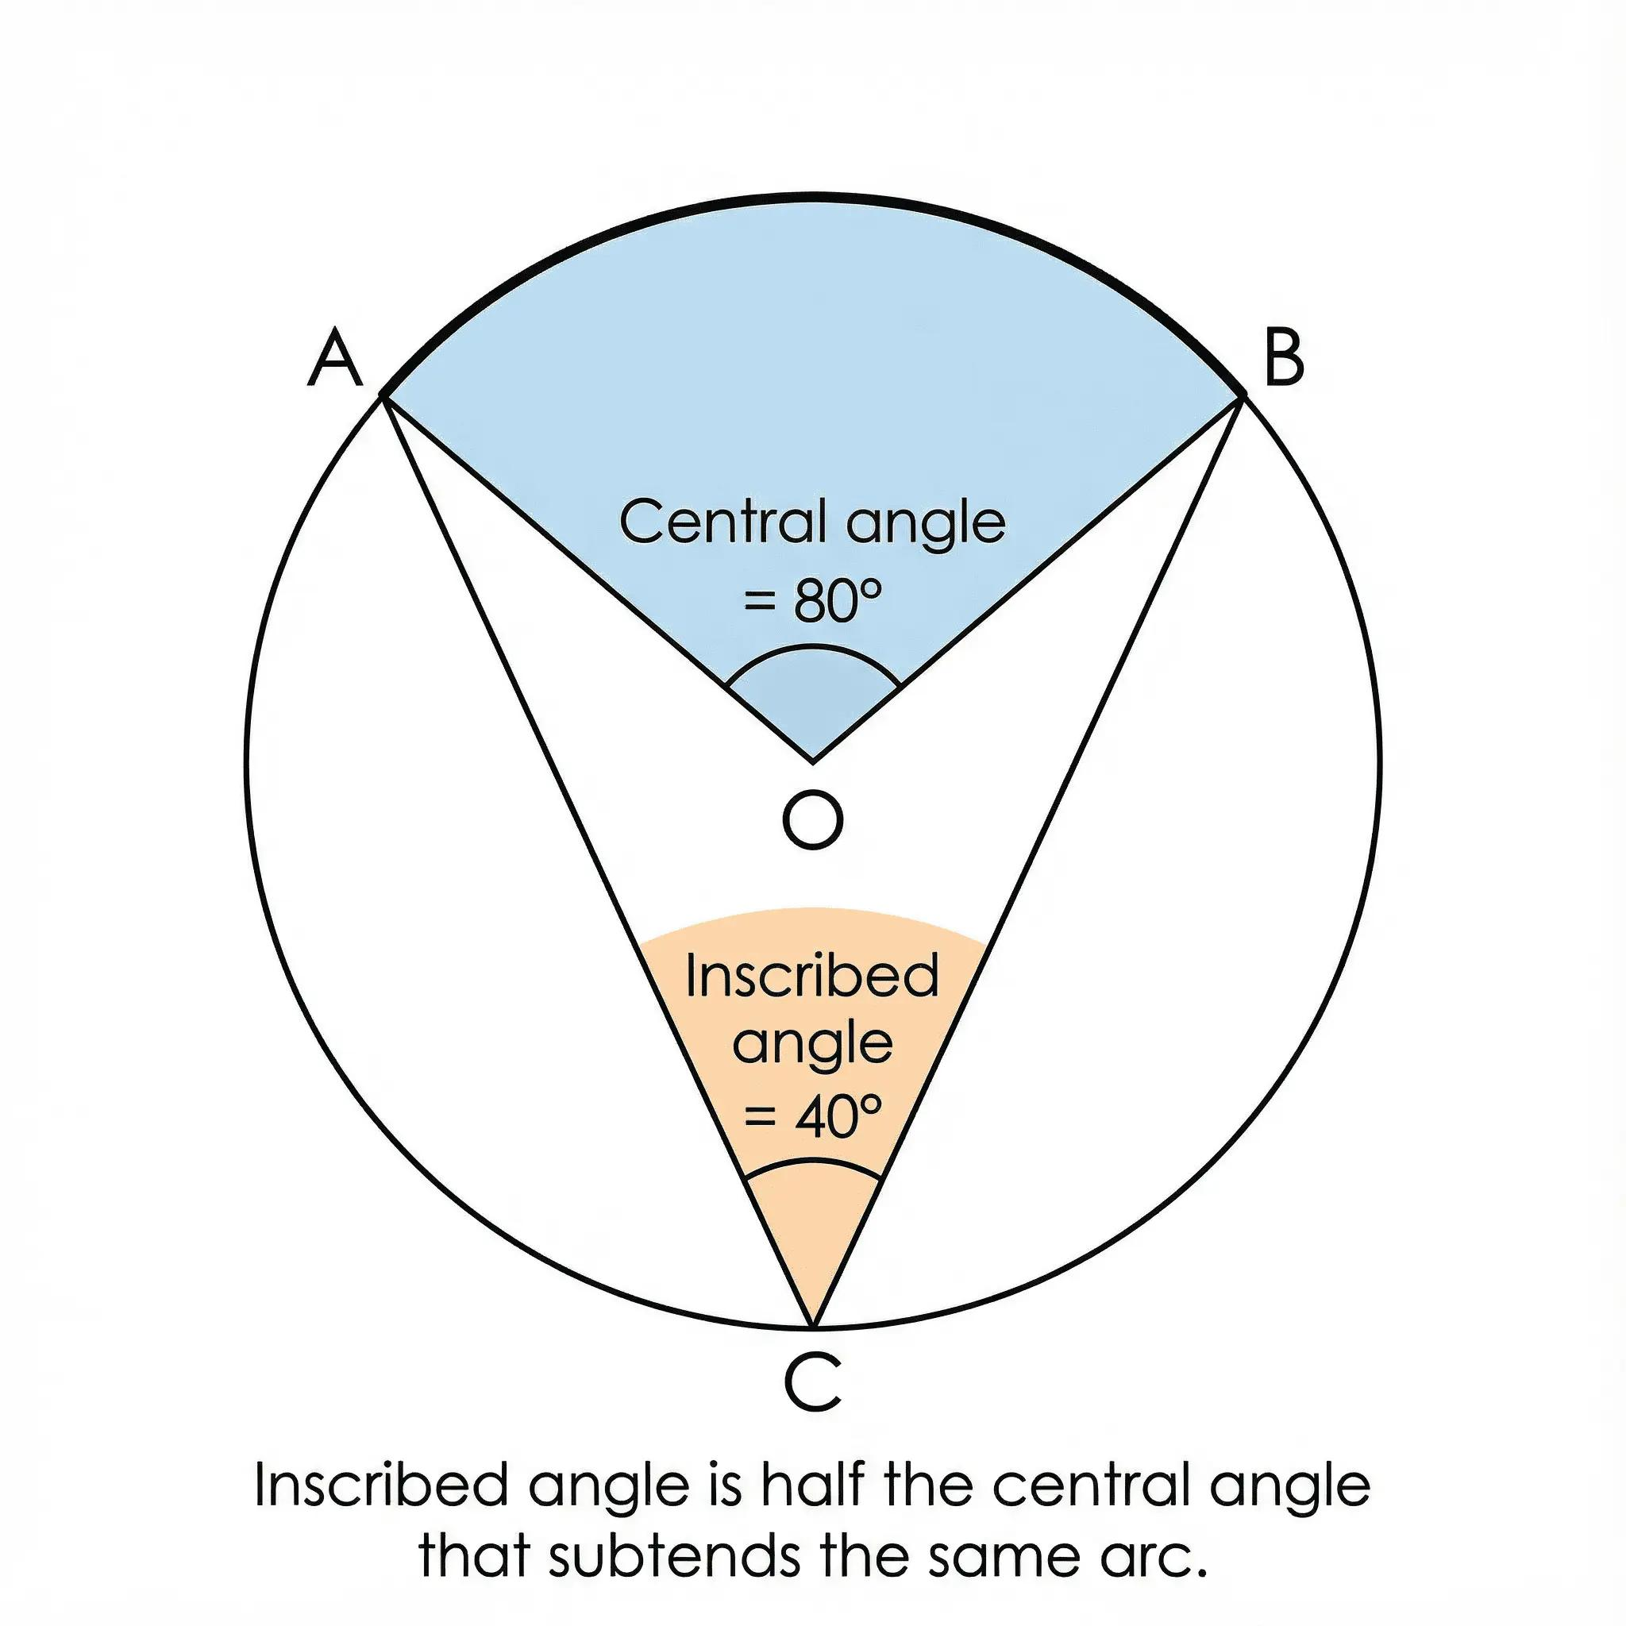
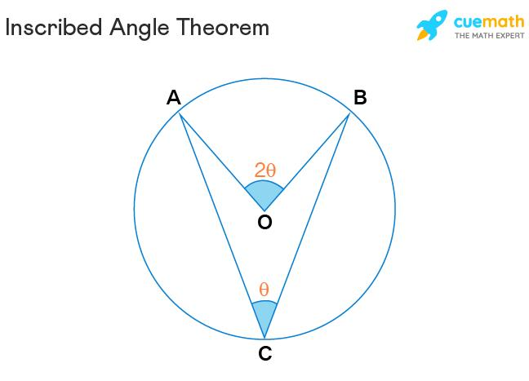
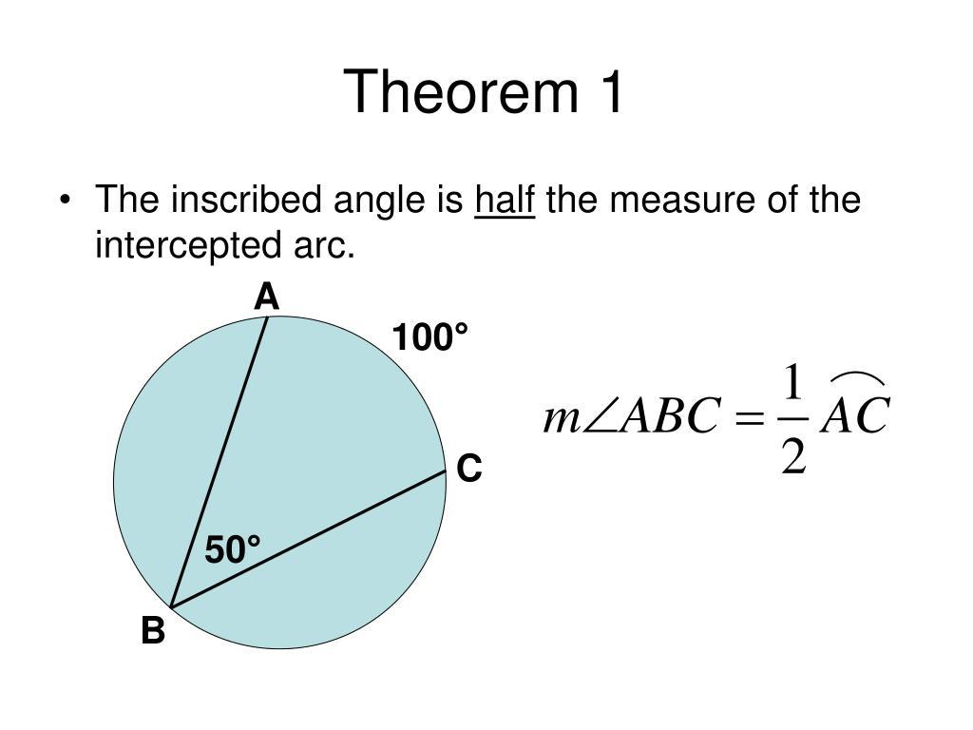
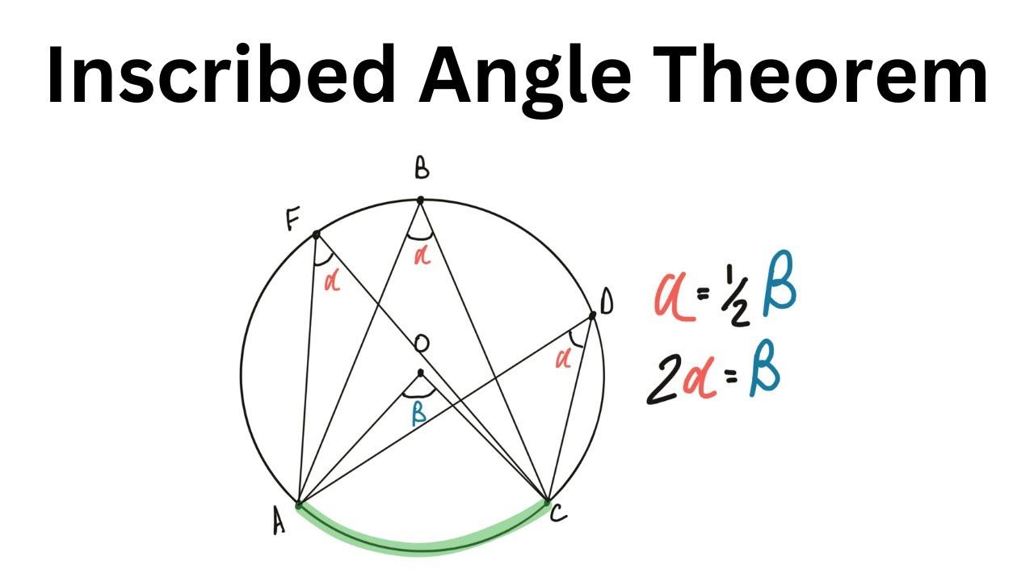

Angle in a Semicircle
# Source: AI Source: Provided by: [Data Path: Persons Table -> ID Column: 1, Name_En Column: Motasem Essam] -> From: [ChatGPT] on [7/25/2026]
An angle subtended by a diameter is a right angle:
$$\boxed{{90}^{∘}}$$
This is the Angle in a Semicircle Theorem.
Symmetry
A circle has:
- Infinitely many lines of symmetry.
- Infinite rotational symmetry.
- Every line passing through the center is a line of symmetry.
- Rotating a circle through any angle about its center leaves it unchanged.
Eccentricity
A circle is a special conic section with eccentricity:
$$\boxed{e=0}$$
This distinguishes it from:
- Ellipse: $0<e<1$
- Parabola: $e=1$
- Hyperbola: $e>1$

Special Parts and Regions
# Source: AI Source: Provided by: [Data Path: Persons Table -> ID Column: 1, Name_En Column: Motasem Essam] -> From: [ChatGPT] on [7/25/2026]
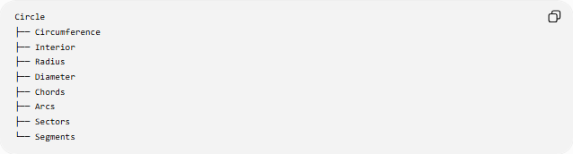
Circle
├── Circumference
├── Interior
├── Radius
├── Diameter
├── Chords
├── Arcs
├── Sectors
└── Segments
The circle can refer to the boundary itself, while the disk refers to the entire region inside and including the boundary.

Examples

Example 1: Finding the Diameter
# Source: AI Source: Provided by: [Data Path: Persons Table -> ID Column: 1, Name_En Column: Motasem Essam] -> From: [ChatGPT] on [7/25/2026]
Given:
$$r=8$$
Then:
$$d=2r=16$$

Example 2: Finding the Area
# Source: AI Source: Provided by: [Data Path: Persons Table -> ID Column: 1, Name_En Column: Motasem Essam] -> From: [ChatGPT] on [7/25/2026]
Given:
$$r=5 \\ A=πr^{2} \\ A=25π$$
Approximately:
$$A≈78.54$$

Example 3: Finding the Circumference
# Source: AI Source: Provided by: [Data Path: Persons Table -> ID Column: 1, Name_En Column: Motasem Essam] -> From: [ChatGPT] on [7/25/2026]
Given:
$$r=10 \\ C=2π\left(10\right)=20π$$
Approximately:
$$C≈62.83$$

Circle as a Conic Section
# Source: AI Source: Provided by: [Data Path: Persons Table -> ID Column: 1, Name_En Column: Motasem Essam] -> From: [ChatGPT] on [7/25/2026]
A circle is one of the four principal non-degenerate conic sections.
It is produced when a plane intersects a cone perpendicular to its axis.

Conic Sections
├── Circle
├── Ellipse
├── Parabola
└── Hyperbola
The circle can also be regarded as a special case of an ellipse in which the two foci coincide with the center.

Real-World Applications
# Source: AI Source: Provided by: [Data Path: Persons Table -> ID Column: 1, Name_En Column: Motasem Essam] -> From: [ChatGPT] on [7/25/2026]
Circles are widely used in:
- Wheels
- Gears
- Clocks
- Coins
- Pipes
- Circular roads
- Bearings
- Pulleys
- Circular tracks
- Mechanical components
- Architecture
- Engineering
- Astronomy
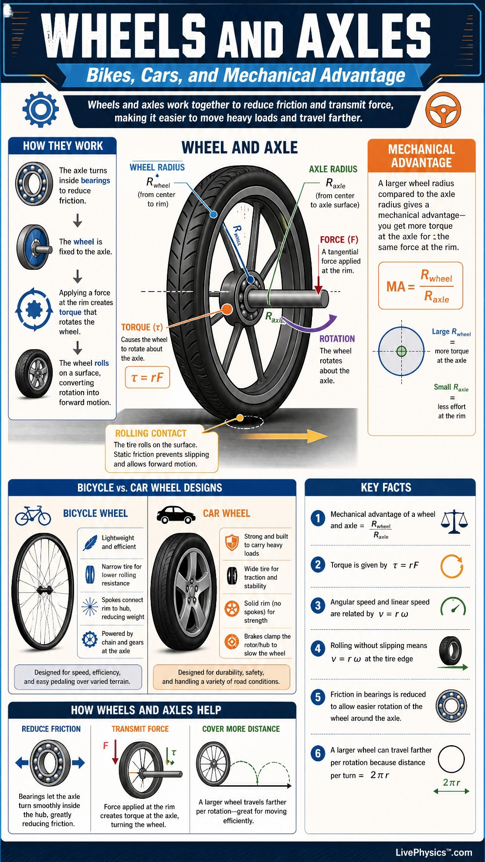
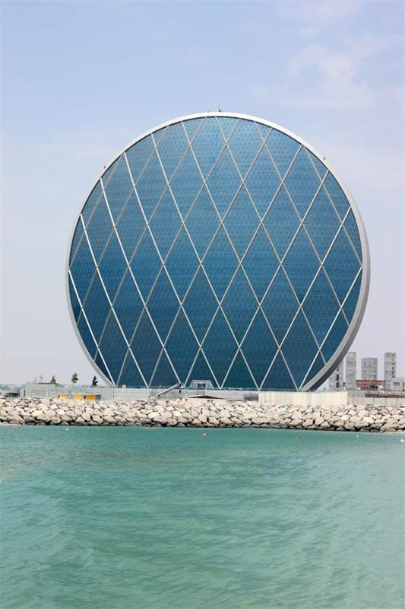
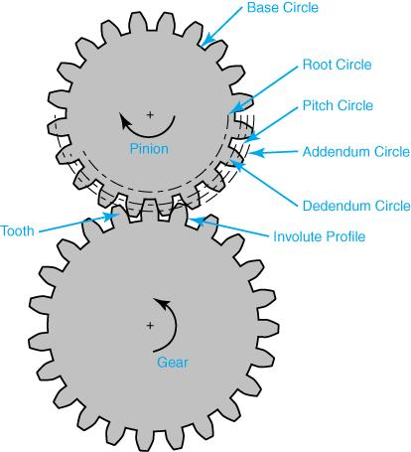

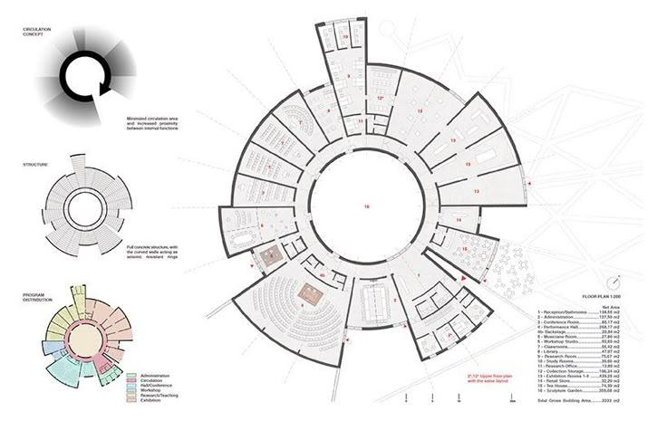

Related Concepts
# Source: AI Source: Provided by: [Data Path: Persons Table -> ID Column: 1, Name_En Column: Motasem Essam] -> From: [ChatGPT] on [7/25/2026]
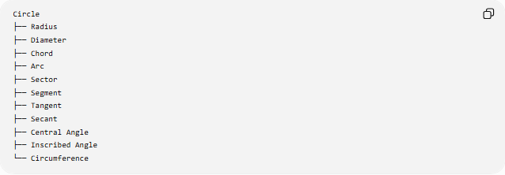
Circle
├── Radius
├── Diameter
├── Chord
├── Arc
├── Sector
├── Segment
├── Tangent
├── Secant
├── Central Angle
├── Inscribed Angle
└── Circumference

Key Formulas
# Source: AI Source: Provided by: [Data Path: Persons Table -> ID Column: 1, Name_En Column: Motasem Essam] -> From: [ChatGPT] on [7/25/2026]
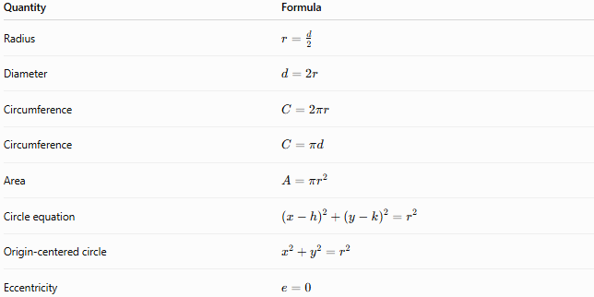
Quantity | Formula
Radius | $$r=\frac{d}{2}$$
Diameter | $$d=2r$$
Circumference | $$C=2πr$$
Circumference | $$C=πd$$
Area | $$A=πr^{2}$$
Circle equation | $${\left(x-h\right)}^{2}+{\left(y-k\right)}^{2}=r^{2}$$
Origin-centered circle | $$x^{2}+y^{2}=r^{2}$$
Eccentricity | $$e=0$$

Key Points
# Source: AI Source: Provided by: [Data Path: Persons Table -> ID Column: 1, Name_En Column: Motasem Essam] -> From: [ChatGPT] on [7/25/2026]
- A circle consists of points equally distant from a center.
- The fixed distance is the radius.
- The diameter is twice the radius.
- The diameter is the longest chord.
- Circumference measures the boundary length.
- Area measures the region enclosed by the circle.
- A circle has infinitely many symmetry lines.
- A circle is a conic section with eccentricity $0$.

Conclusion
# Source: AI Source: Provided by: [Data Path: Persons Table -> ID Column: 1, Name_En Column: Motasem Essam] -> From: [ChatGPT] on [7/25/2026]
A circle is one of the fundamental geometric shapes and is defined by the constant distance of every point on its circumference from a common center. Its basic measurements are determined by the radius, with the principal formulas:
$$\boxed{d=2r} \\ \boxed{C=2πr} \\ \boxed{A=πr^{2}}$$

